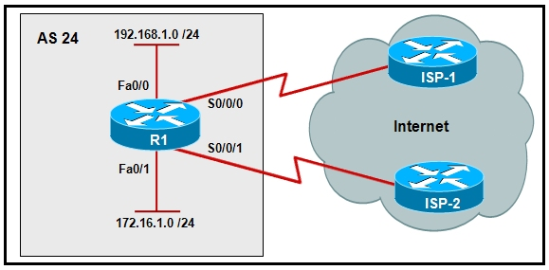

Refer to the exhibit. Which configuration will ensure that traffic that originates from network 172.16.1.0 will be forwarded out Serial 0/0/0?

R1(config)# **access-list 1 permit 172.16.1.0 0.0.0.255**   
R1(config)# **route-map ISP-1 permit 10**  
R1(config-route-map)# **match ip address 1**  
R1(config-route-map)# **set interface s0/0/0**  
R1(config)# **interface fa0/1**  
R1(config-if)# **ip policy route-map ISP-1**

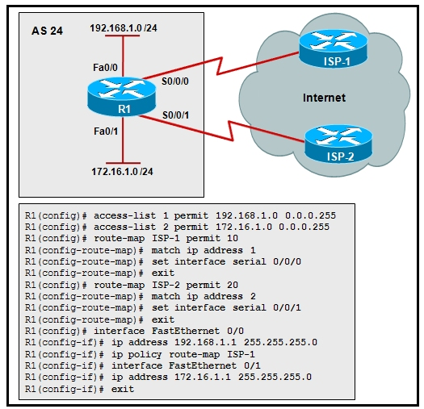

Refer to the exhibit. The routing policy for router R1 states that traffic from the 192.168.1.0 LAN network is to be routed to ISP-1 and traffic from the 172.16.1.0 LAN network is to be routed to ISP-2. However, the network administrator notices that a host at IP address 172.16.1.10 is being routed out Serial0/0/0. What is the cause of the problem?

Answer: The route map ISP-2 should be applied to FastEthernet0/1.

You have created and IPv6 ACL called **MY-LIST**. Which command would you configure to use this ACL to check inbound packets on an interface?

**ipv6 traffic-filter MY-LIST in**